What lessons can we learn from China’s rapid growth?

China is a challenging country to define. The dominant narrative across much of the world is of China as a rising hegemon, the next great superpower, a global economic powerhouse. But while it is true that China has experienced an astonishing transformation in its economic and geopolitical status over the past 30 years, this one-sided view of China fails to capture the complexity of the country and how it got to where it is today.
Rather than talk about “one China” as a single entity, I would like to explore three different Chinas that I see today. I hope this will give a fuller picture of how we can understand the country and its potential as a partner in global health and development.
First, there’s China, the major global power. Over the past 30 years China has built up the world’s second largest economy, tipped to overtake the US within the next decade. Back in the early 1980s, China’s GDP (Gross Domestic Product ) per capita was lower than India’s; by 2000, it was already twice that of India’s and the gap continues to widen.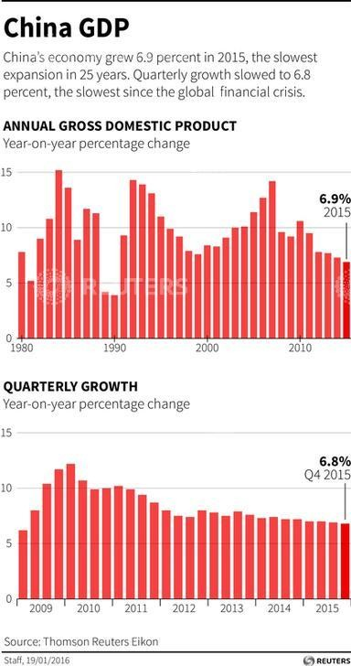
China’s astonishing growth over the past 30 years, driven in large part by the government’s focus on agricultural development, is unprecedented in its scale and persistence; even as its economy slows, China can still boast growth that most other countries can only dream of. The country’s leadership is relying on R&D to play an important part in helping China to transition to a service-based economy, placing innovation at the center of its plan for Chinese development over the next five years. Chinese R&D (Research and Development) spending currently accounts for an impressive 15% of the world’s total and this is only likely to increase.
Second, we have China, the developing country. Given the prevailing focus on its rapid economic rise, it is easy to forget that poverty remains one of its greatest challenges. Seventy million Chinese people still live in extreme poverty (compared with 300 million in India, 100 million in Nigeria, and 25 million in Ethiopia), struggling to survive, often in appalling conditions. While China’s economic success over the past decades has indeed been remarkable, the sheer size of its population means that, in terms of GDP per capita, it still ranks only 83rd in the world. What’s more, it suffers from dangerous levels of income inequality, with a Gini coefficient of 0.462.
The vast majority of China’s poor live in rural areas, which have benefited much less from the growth driven by the powerhouse cities of the east and where people still rely heavily on agriculture and subsistence farming. Agriculture remains a key pillar of the Chinese economy; 35% of the world’s farms are in China (compared to 9% in sub-Saharan Africa) and, even today, 50% of the population remains in the rural agricultural sector. Rural poverty is further compounded by China’s enormous health burden; the country has the world’s third largest TB epidemic, for example, and more than a million Chinese people die every year as a result of smoking.
Third, there’s China, the development partner. With a truly remarkable track record, China is undoubtedly a world-leader in poverty reduction and improving health outcomes and there is a lot the rest of the world can learn from its experience. Last year the world celebrated the success of the Millennium Development Goals (MDGs) and set out new targets to reach by 2030. The first of the MDGs, to halve global poverty within 15 years, was realized several years before the 2015 deadline, a spectacular achievement. But China would be justified in claiming considerable credit for this success; an astonishing 439 million of the approximately one billion people lifted out of extreme poverty since 1990 were Chinese. In 2015, the UNDP (United Nation Development Program) calculated that China had contributed 76% of all global poverty reduction to date.
China also led the world in achieving other MDGs, with the world’s fastest rate of decline in both maternal and child mortality. By 2013, China’s maternal mortality rate was even lower than that of the US. China has waged a successful campaign against malaria, largely without any external assistance, reducing case numbers from 24 million in 1970 to just 57 cases of local transmission in 2014. It is on its way to total elimination of malaria by 2020. Learning from China’s unprecedented successes could be hugely valuable to other developing countries facing similar challenges, especially as the world moves towards achieving the Sustainable Development Goals.
As China continues to take a more active role on the global stage, it is in an ideal position to partner more closely with other developing countries and share the lessons it has learned from its own experience. At the Bill & Melinda Gates Foundation, we see these “three Chinas” as core to our understanding of China as a whole, and we hope to continue working together with China to tap into its innovation power, to address some of China’s own acute health and development challenges, and as an invaluable development partner for the rest of the world.

